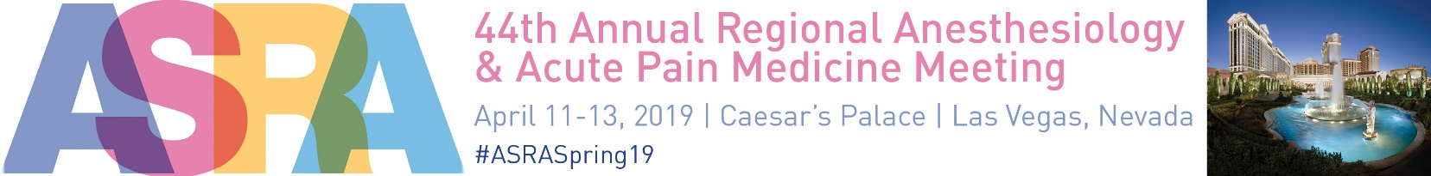

**SUPPORT & EXHIBITION BOOKING FORM**

Please complete all details and return to:

Jack Edelman / email: [jack.edelman@ajj.com](mailto:jack.edelman@ajj.com) / phone: 856-256-2313 / fax: 856-589-7463

**CONTACT/BILLING INFORMATION**

**Contact name:**

**\*Name of Company:**

**Address:**

**City:** **State:** **Zip code:**

**Telephone:** **/****/****Fax:** **/****/**

**Email:** **Website:**

*\*Please note this is how your company and products/services information will appear on all meeting related materials.*

I would like to book the follow support/exhibition:

|  |  |  |
| --- | --- | --- |
| **SPONSORSHIP SUPPORT PACKAGES** | | |
| **Item** | **Price** | **Total** |
| Platinum Sponsorship | $50,000 |  |
| Gold Sponsorship | $25,000 |  |
| Silver Sponsorship | $15,000 |  |
| Bronze Sponsorship | $10,000 |  |
| **SUPPORT/SPONSORSHIP PROMOTIONAL OPPORTUNITIES** | | |
| **Item** | **Price (check off item)** | **Total** |
| Non-CME Ancillary Event Fee | $25,000 /  $29,000 Day   /  , Time: |  |
| Ancillary Event Misc. Meeting Space | $1,500 per room per day (complete 4th page with specifics) |  |
| Mobile Meeting App | $10,000 |  |
| WiFi / Internet Café Chat Room | $10,000 |  |
| Meeting Bags | $ 9,500 |  |
| Hotel Key Cards | $ 8,500 |  |
| Meeting Lanyards | $ 7,500 |  |
| Program Guide Advertisement | $ 4,000  $3,000  $2,500 |  |
| Floor Decals/Window Clings | $ 3,000 (includes 5 floor decals/window clings), x |  |
| Saturday Celebration Package | $ 2,000 |  |
| Wine/Bubbly Pour Host | $ 2,000 |  |
| Promotional Material Distribution | $ 1,750 |  |
| Free Standing Meter Board Sign | $ 1,500 (each) x |  |
| Table Tents | $ 1,250 (includes 5 table tents) x |  |
| **TOTAL AMOUNT** |  |  |

Please call me to discuss our Support Packages/Opportunities

|  |
| --- |
| **EXHIBITION BOOTH SPACE** |

10’x10 Inline Booth $ 3,450

10’x10’ Corner Booth $ 3,550

Island Booth Space $35.50 (per net square feet)

|  |  |  |  |
| --- | --- | --- | --- |
| **Choice** | **Booth Number** | **Booth Size** | **Total Price** |
| 1st Choice |  |  | $ |
| 2nd Choice |  |  | $ |
| 3rd Choice |  |  | $ |
| 4th Choice |  |  | $ |

|  |  |  |
| --- | --- | --- |
| **ASRA Office Use Only** | | |
| **Received:** | **ASRA Point System:** | **Booth #** |

Special notes: Please indicate if you would like to avoid placement near any of the following companies, of if special configuration is needed:

No, We do not require pipes and drapes  Yes, We would require pipes and drapes

No, We do not require the furniture  Yes, We would require the furniture

*(6’ draped table, two chairs and one wastebasket) (6’ draped table, two chairs and one wastebasket)*

**Description and Logo:** (100 words or less)

Please send a 100-work exhibitor company/product profile and company logo (in 300 dpi .eps, .jpg or .pdf format) to:

[heidi.perret@ajj.com](mailto:heidi.perret@ajj.com).

Payment will be made by check, please forward me a final confirmation/invoice.

Payment will be made by credit card  Credit Card Authorization Form is included

Please send me a first deposit invoice for 100% of the total amount due.

We accept the contract terms and conditions (listed in this support and exhibition prospectus) and agree to abide by the guidelines for industry participation for the meeting. I am authorized to sign this form on behalf of the applicant/company.

Signature (required)       Date:

Complete the attached page if you are requesting Meeting Space during the ASRA 2019 Regional Anesthesiology & Acute Pain Medicine Meeting.





**44th Annual Pain Medicine Meeting**

April 11-13, 2019 / Caesar’s Palace / Las Vegas, Nevada

**CREDIT CARD AUTHORIZATION FORM**

In order to charge your credit card and in accordance with the security measures taken by credit card companies, please fill in the following form and return.

Please send this sheet by fax or email scan to the attention of:

Heidi Perret

ASRA Marketing Coordinator

Fax: 856-589-7463

Email: heidi.perret@ajj.com

**Authorization for Credit Card Charges**

Name of company:

We authorize ASRA to make the charge of: (US currency only) $

For the following services:

For meeting:

Credit card details to be charged:

AMEX  VISA  MC

Number:

Expiration date:  /   Security Code

Name of card holder:

Address: (as per credit card records):

City:       State:    Zip Code:

Country:

Telephone number:    -   -

Email Address for receipt:

Signature of card holder:       Date:   /  /

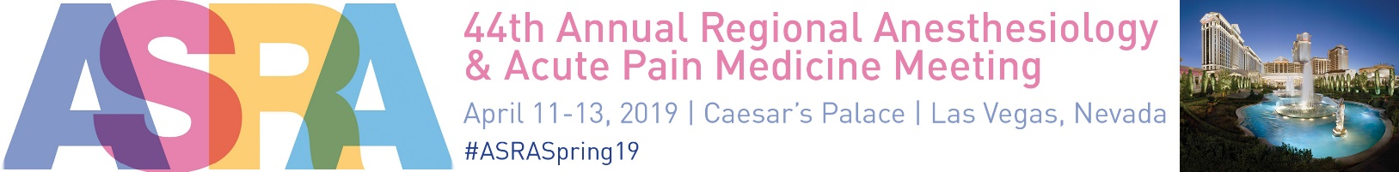

**MEETING SPACE REQUEST FORM**

Please complete the below for each meeting space requested and return with your booking form to:

Jack Edelman / email: [jack.edelman@ajj.com](mailto:jack.edelman@ajj.com) / phone: 856-256-2313 / fax: 856-589-7463

**CONTACT/BILLING INFORMATION**

**Contact name:**

**Name of Company:**

**Address:**

**City:       State:    Zip code:**

**Telephone:    /   /     Email:**

*Please Note: Exhibiting company is responsible for all AV and/or food & beverage in the meeting room(s).*

**Date of Meeting #1:**

**Time:**

**Number of People:**

**Requested Room Set:**

**Who will be attending:**

**Purpose of Meeting:**

**Date of Meeting #2:**

**Time:**

**Number of People:**

**Requested Room Set:**

**Who will be attending:**

**Purpose of Meeting:**

**Date of Meeting #3:**

**Time:**

**Number of People:**

**Requested Room Set:**

**Who will be attending:**

**Purpose of Meeting:**