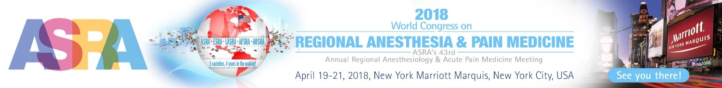

IN KIND SUPPORT

World Congress on Regional Anesthesia & Pain Medicine /
43rd Annual Regional Anesthesiology & Acute Pain Medicine Meeting

April 19-21, 2018

Jack Edelman / Account Executive
Email: jack.edelman@ajj.com / Tel: 856-256-2313 / Fax: 856-589-7463

If you wish to provide equipment for the World Congress Regional Anesthesia & Pain Medicine please complete the following request, and return no later than February 1, 2018:

Contact name:

Name of company:

Address:

City: State: Zip code:

Telephone: / / Fax: / /

Email: Website:

Yes, I would like to provide in kind support for workshops.
We can supply US machines and/or supplies for the workshops

What type of machine and/or supplies will you be supplying?

Signature: Date: / /
Thank you.

