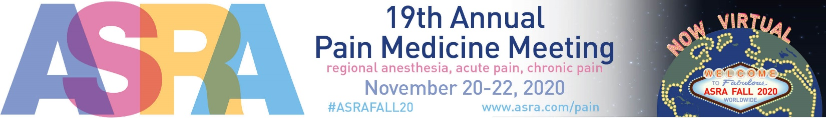
ASRA Virtual Terms and Conditions
- APPLICATION, FEES, PAYMENTS, CANCELLATIONS
- Except as provided to the contrary in this contract, all monies paid by Exhibitor shall be deemed full earned and non-refundable at the time of payment.
- If you must cancel your booth reservation at any time, you must submit a cancellation request in writing to the Show Management.
- Applications for rental of virtual exhibit space shall be subject to the approval of Show Management, and Show Management reserves the right to reject applications for space with or without cause if Show Management determines the rejection is in the best interest of the Show. Upon acceptance of the Virtual Exhibit Space Agreement by Show Management, its contents, as modified if applicable, shall become a legally binding agreement for exhibit space between the Virtual Exhibitor and Show Management, subject to the terms and conditions herein.
- Exhibit Fees. The cost for exhibit space is dependent on the sponsorship level, Vbooth type, and Vbooth amenities. Virtual Exhibitor must be fully paid on all money owed to ASRA, including sponsorship, and advertising.
- Payment Schedule. Payments may be made by credit card, wire transfer or check (in U.S. funds drawn on a U.S. bank only). Checks must be made payable to ASRA and mailed to East Holly Ave., Box 56, Pitman, NJ, 08071. Virtual Exhibitor has the following options for payment of their virtual booth space or sponsorship package:
  - Payment Option 1: 100% deposit submitted upon receipt of application approval by business check, money order or wire transfer to ASRA’s bank.
  - Payment Option 2: 100% deposit submitted upon receipt of application approval by credit card.*
*ASRA charges a 2% fee to any credit card transaction over $4000
- At its discretion, if at any time Show Management deems a virtual exhibit, or an exhibit’s contents objectionable, Show Management reserves the right to remove and/or cancel the exhibit space or any portion thereof at Exhibitor’s sole expense. In the event the right is exercised during the Show, Show Management shall not be liable for refund of Virtual exhibit space fees, or any other expense incurred by reason of Show Management’s removal of objectionable contents or cancellation of the exhibit space or any portion thereof. Exhibitor hereby expressly waives any and all rights and claims, actions and demands for damages, costs and expenses, including without limitation, legal fees, lost profits, and costs of goods sold, against the virtual hosting platform, Show Management, their directors, officers, agents, employees and/or servants for such removal and/or cancellation.
- ELIGIBILITY
Show Management reserves the right to determine or verify eligibility of Exhibitor for inclusion in the Show prior to, or after, submission of the Virtual Exhibit Space Agreement. Show Management will determine the appropriateness of products to be exhibited by their distinctive characteristics or performance capability.
- Non-Exhibiting Company Products or Services. Exhibitor may not display products or signage in their vBooth from eligible non-exhibiting companies unless approved in writing by Show Representations by and/or media activities of non-exhibiting companies are prohibited at the Show.
- OPERATION AND CONDUCT
- Exhibit Personnel.
  - Virtual Exhibitor may not harass or antagonize another party or attendee.
  - No area of the ASRA platform shall be used for any improper, immoral, illegal or objectionable purpose.
- Incidents. Any incident involving or occurring in Exhibitor’s vBooth, or as it relates to vBooth personnel are the express responsibility of the Virtual Exhibitor.
- VIOLATIONS
The Exhibitor shall be bound by the Rules as defined herein, and by such additional rules and regulations which may be established by Show Management at any time. Show Management shall enforce all Rules and such additional rules and regulations, and its decision on these matters will be final. All matters and questions not covered by the Rules and such additional rules and regulations shall be subject to the final judgment and decision of Show Management.
- FAILURE TO HOLD EXPOSITIONS
Should any contingency prevent holding of the Exposition, ASRA may retain such part of exhibitor’s rental as shall be required to pay for expenses incurred up to the time such contingency shall have occurred. The exhibitor waivers all claim for damage or recovery of payments made except the return of the prorated amount paid for exhibit space less expenses incurred by ASRA and the event platform.

