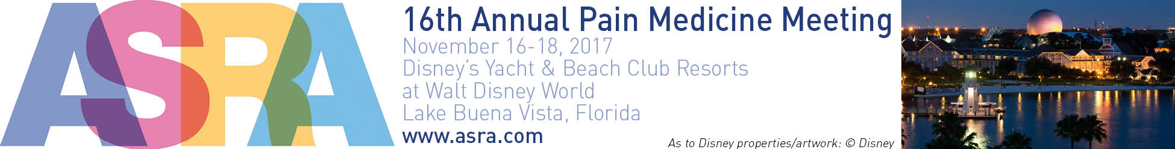

SUPPORT & EXHIBITION BOOKING FORM
Please complete all details and return to:
Jack Edelman / email: jack.edelman@ajj.com / phone: 856-256-2313 / fax: 856-589-7463

CONTACT/BILLING INFORMATION

Contact name:
*Name of Company:
Address:
City: State: Zip code:
Telephone: / / Fax: / /
Email: Website:
*Please note this is how your company and products/services information will appear on all meeting related materials.

I would like to book the follow support/exhibition:

EXCLUSIVE SUPPORT PACKAGES
Item | Price | Total
Platinum Sponsorship | ☐ $50,000
Gold Sponsorship | ☐ $25,000
Silver Sponsorship | ☐ $15,000
Bronze Sponsorship | ☐ $10,000
SUPPORT/SPONSORSHIP PROMOTIONAL OPPORTUNITIES
Item | Price (check off item) | Total
Non-CME Ancillary Event Fee | ☐ $25,000 / ☐ $29,000 Day / , Time:
Ancillary Event Misc. Meeting Space | ☐ $1,500 per room per day (complete 3rd page with specifics)
Mobile Meeting App | ☐ $10,000
WiFi / Internet Café Chat Room | ☐ $10,000
Meeting Bags | ☐ $ 9,500
Meeting Lanyards | ☐ $ 7,000
Program Guide Advertisement | ☐ $ 4,000 ☐ $3,000 ☐ $2,250
Notepads & Pens | ☐ $ 3,500 + notepads & pens
Saturday Celebration Package | ☐ $ 2,000
Promotional Material Distribution | ☐ $ 1,750
Floor Decals/Window Clings | ☐ $ 1,750 (includes 5 floor decals/window clings), x
Free Standing Meter Board Sign | ☐ $ 1,500 (each) x
Wine/Bubbly Pour Host | ☐ $ 1,500
Table Tents | ☐ $ 1,250 (includes 5 table tents) x
TOTAL AMOUNT

☐ Please call me to discuss our Support Packages/Opportunities
EXHIBITION BOOTH SPACE

10’x10 Inline Booth $ 3,300
10’x10’ Corner Booth $ 3,400
Island Booth Space $33.00 (per net square feet)

Choice | Booth Number | Booth Size | Total Price
1st Choice |  |  | $
2nd Choice |  |  | $
3rd Choice |  |  | $
4th Choice |  |  | $

ASRA Office Use Only
Received: | ASRA Point System: | Booth #

Special notes: Please indicate if you would like to avoid placement near any of the following companies, of if special configuration is needed:

☐ No, We do not require pipes and drapes ☐ Yes, We would require pipes and drapes
☐ No, We do not require the furniture ☐ Yes, We would require the furniture
(6’ draped table, two chairs and one wastebasket) (6’ draped table, two chairs and one wastebasket)

Description and Logo: (100 words or less)
Please send a 100-work exhibitor company/product profile and company logo (in 300 dpi .eps, .jpg or .pdf format) to:
heidi.perret@ajj.com.

☐ Payment will be made by check, please forward me a final confirmation/invoice.
☐ Payment will be made by credit card ☐ Credit Card Authorization Form is included
☐ Please send me a first deposit invoice for 100% of the total amount due.

We accept the contract terms and conditions (listed in this support and exhibition prospectus) and agree to abide by the guidelines for industry participation for the meeting. I am authorized to sign this form on behalf of the applicant/company.

Signature (required) Date:

Complete the following page if you are requesting Meeting Space during the ASRA 2017 Pain Medicine Meeting.

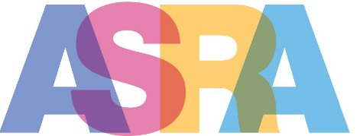

MEETING SPACE REQUEST FORM
Please complete the below for each meeting space requested and return with your booking form to:
Jack Edelman / email: jack.edelman@ajj.com / phone: 856-256-2313 / fax: 856-589-7463

CONTACT/BILLING INFORMATION

Contact name:
Name of Company:
Address:
City: State: Zip code:
Telephone: / / Email:

Please Note: Exhibiting company is responsible for all AV and/or food & beverage in the meeting room(s).

Date of Meeting #1:
Time:
Number of People:
Requested Room Set:
Who will be attending:
Purpose of Meeting:

Date of Meeting #2:
Time:
Number of People:
Requested Room Set:
Who will be attending:
Purpose of Meeting:

Date of Meeting #3:
Time:
Number of People:
Requested Room Set:
Who will be attending:
Purpose of Meeting:

